**Assignment 1: Linux basic Commands ( 03/01/2022 )**

**Need to maintain a google doc file with(with public permission):**

* **Name of the Task**
* **Commands used and what are they used for**
* **Attach Screen shot which includes**
* **Execution of commands sequence**
* **Result of Execution**

**Tasks:**

* **1 Install OpenSSH, nano, htop**
* **2 Create a folder**
* **3 Create one file add 100’s of lines inside**
* **4 Create a copy of the file with _copy.txt in name**
* **5 Try head and tail**
* **6 Add current path of inside file inside Task 3 file at the end.**
* **7 Create a file without opening**
* **8 Rename all 3 files**
* **9 Delete all the files containing _copy.text at the end**
* **10 Check all the running processes**
* **11 Find the location of the python**
* **12 Check your current IP address and share it to a friend**
* **13 Check IP address of** [**weboccult.com**](http://weboccult.com/)

**1 Install OpenSSH**

**sudo apt-get install openssh**

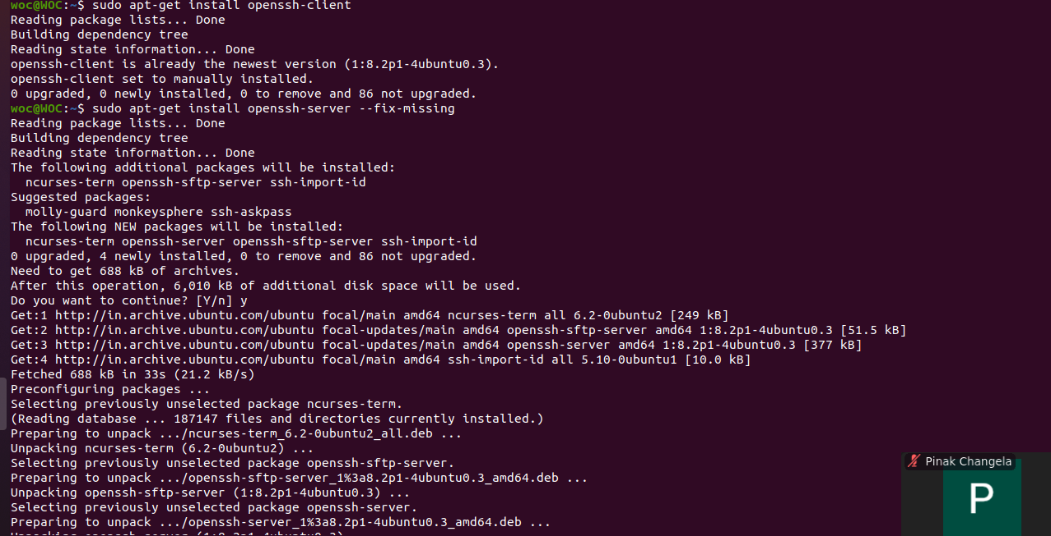

**Install nano**

* **sudo apt-get install nano**

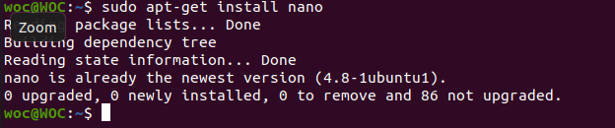

**Install htop**

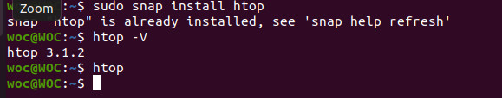

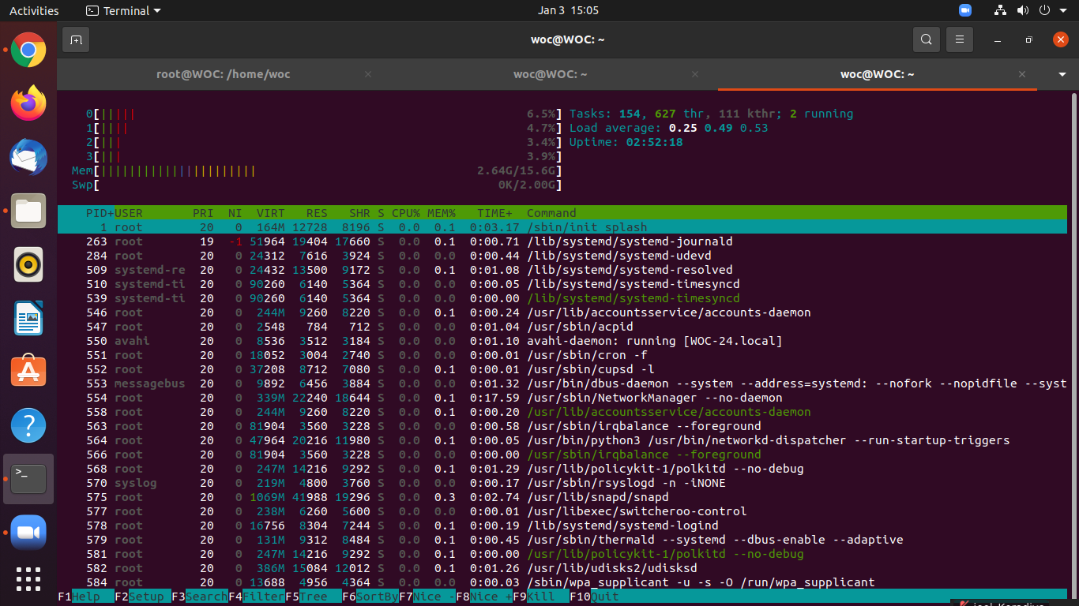

**2 Create a folder**

**Use : mkdir command is use to create directory.**

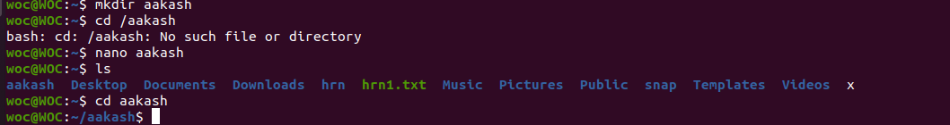

**3 Create one file add 100’s of lines inside**

**Use: Vi is use to create new file**





**4 Create a copy of the file with _copy.txt in name**

**Use : Copy a file content into new file**



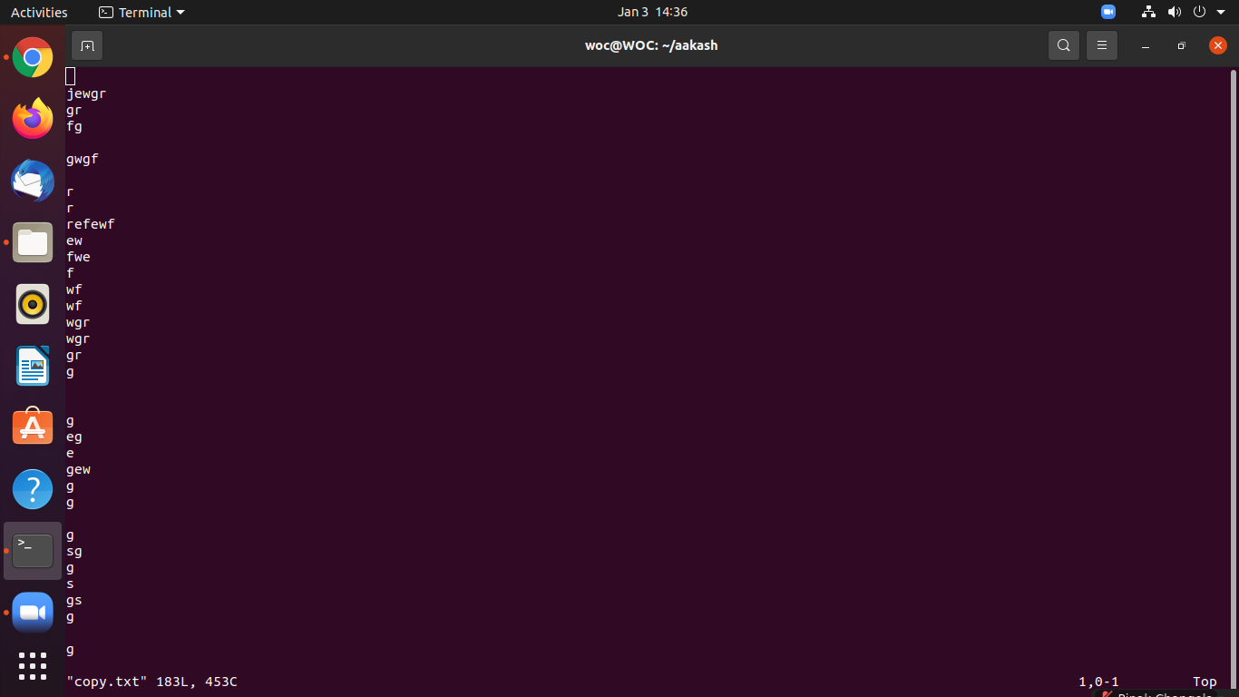

**5 Try head and tail**

**Head Command: it is use to print top 10 line from file.**

**Tial Command: It is use to print bottom 10 line from file.**

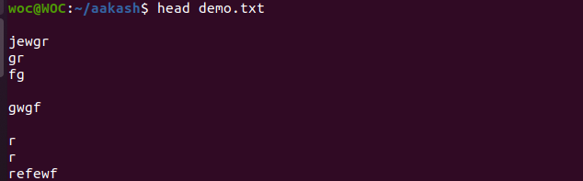

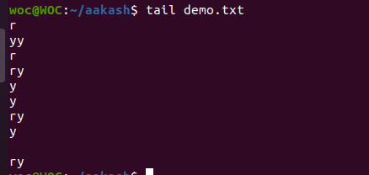

**6 Add current path of inside file inside Task 3 file at the end.**

**Use : echo is use print**

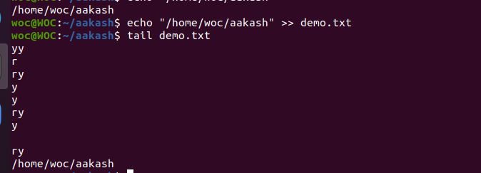

**7 Create a file without opening**

**Touch Command is use to create a file without opening the file.**



**8 Rename all 3 files**

**Use: mmv is use rename multiple file**

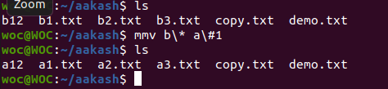

**9 Delete all the files containing _copy.text at the end**

**Rm command is use remove the file**

* 



**10 Check all the running processes**

**Top command is use to show all the running process in system**

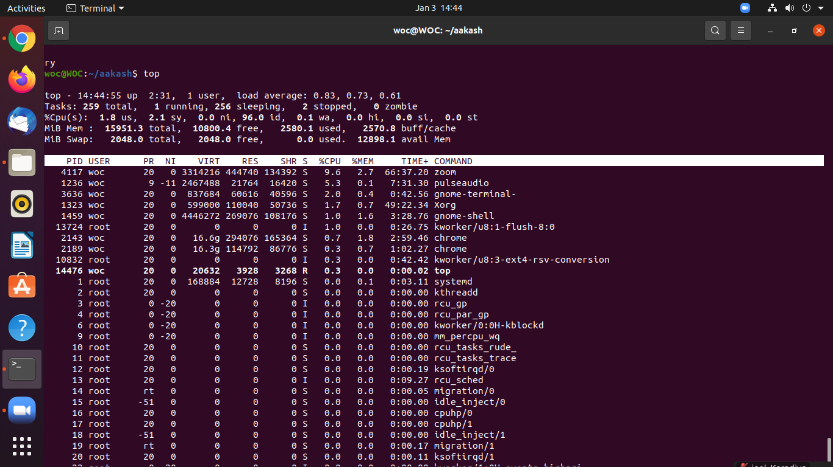

**11 Find the location of the python**



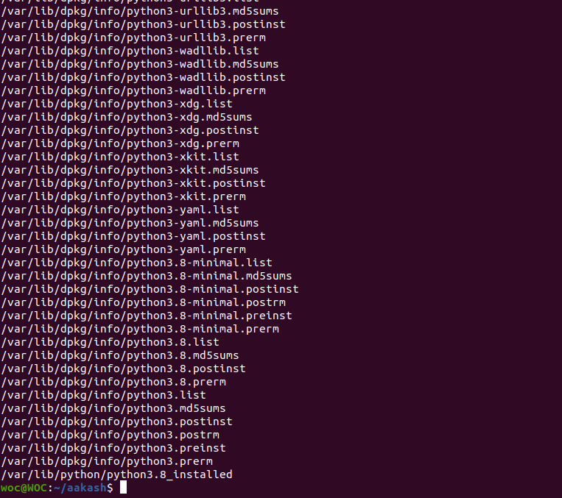

**12 Check your current IP address and share it to a friend**

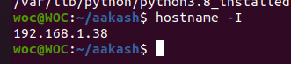

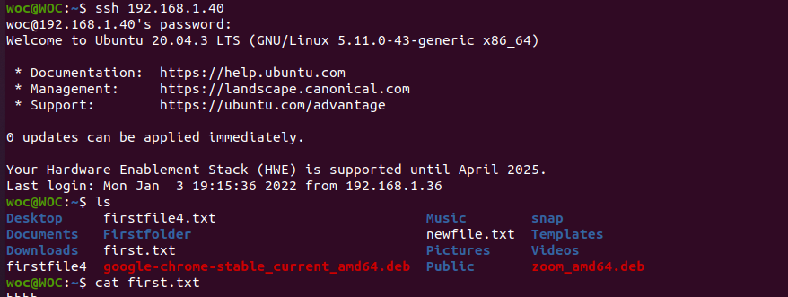

**13 Check IP address of** [**weboccult.com**](http://weboccult.com/)

